SIMATS ENGINEERING (SAVEETHA SCHOOL OF ENGINEERING)
Department of Computer Science and Engineering
CO2_AT3 — CASE STUDY

Course Code: | DSA06 | Course Title: | Data Handling and Visualization
CO Assessed: | CO2 – Evaluation (BL5) | Assessment: | Assessment Tool 3 – Case Study
Weightage: | 20% of CIA | Total Marks: | 20 (2 Questions × 10 Marks)
CO2 Statement: | Analyze real-world data scenarios and evaluate/justify the most appropriate chart types, coordinate systems, color scales, and dashboard designs to represent them.(BL5)
Student Name: | K. Amrutha Sandhya | Reg. No.: | 192524270
Section / Batch: | AIDS | Date: | 01-08-2026

Code of Conduct
I K. Amrutha Sandhya(192524270)_ (Name / Reg No) certify that this submission is my original work and that I have adhered to the guidelines specified for this assessment. I understand that any violation of academic integrity rules will result in disciplinary action.

Signature of the Student: Amrutha

Instructions
- This test contains 2 case-study questions, each carrying 10 marks. Total: 20 Marks.
- No negative marking. Unanswered questions carry zero marks.
- No calculators or electronic devices permitted.
- Duration: 90 minutes.
- Each case study has four sub-parts (a–d); answer all parts for full marks.
- Support your answers with brief calculations or justifications where relevant.
- Diagrams may be hand-drawn or clearly described in words if drawing tools are unavailable.

Annexure A – CASE STUDY

Rubrics for Calculation ASSESSMENT RUBRIC
AT3 — Case Study
CO2 · BT5: Evaluate ·
This rubric is used to assess student responses to the CO2-AT3 Case Study questions, in which students analyze a realistic multi-part scenario and select, justify, design, and critique appropriate visualizations across chart types, coordinate systems, color scales, and dashboard development.

Criteria | Weightage | Level 4 – Exemplary | Level 3 – Proficient | Level 2 – Developing | Level 1 – Beginning
Understanding of Concepts | 25% | Demonstrates thorough understanding of the full range of chart types, coordinate systems, and color scales relevant to the case, and correctly identifies which apply to each sub-part. | Good understanding of the relevant concepts, with only minor gaps in identifying appropriate chart types, scales, or color choices. | Basic understanding, but with some misconceptions about which visualization techniques suit the scenario's data. | Poor understanding of core concepts; proposes techniques fundamentally unsuited to the case study's data.
Explanation | 25% | Provides detailed, well-reasoned justification for every design decision and critique, explicitly tied to specific details of the case. | Provides clear justification for most decisions and critiques, with adequate reasoning. | Justification is limited or generic; decisions are stated without sufficient reasoning tied to the case. | Little or no justification provided; answers are unsupported assertions.
Application | 20% | Effectively applies visualization concepts to analyze and solve every sub-part of the case, including any calculations, with well-reasoned conclusions. | Applies concepts correctly to most sub-parts, with only minor errors. | Limited application; some sub-parts are weakly addressed or only partially correct. | Fails to apply appropriate concepts; sub-parts are left unaddressed or answered incorrectly.
Organization | 15% | The response is clearly structured, addressing every sub-part (a–d) in a logical sequence with coherent overall flow. | The response is organized and addresses each sub-part, with only minor issues in flow or clarity. | Basic structure; sub-parts are addressed but the response lacks clarity or a logical sequence. | Poorly organized; the response is incoherent, and sub-parts are left unaddressed or answered out of order.
Accuracy | 10% | All parts of the answer — chart choices, calculations, critiques, and dashboard design — are completely accurate and well-suited to the case. | Mostly accurate, with only minor omissions or a small error in one sub-part. | Partially correct; some elements are missing, mismatched to the case, or incorrect. | Largely incorrect or inappropriate, with major gaps across multiple sub-parts.

Scoring Guide
For each criterion, award a performance level (1–4) based on the descriptors above. Multiply the level achieved (as a percentage of 4, i.e., Level 4 = 100%, Level 3 = 75%, Level 2 = 50%, Level 1 = 25%) by the criterion's weightage, then sum across all five criteria to obtain the total score out of 100%.

Faculty In-charge | Course Coordinator | Head of Department
Signature: _______________ | Signature: _______________ | Signature: _______________
Date: ___________________ | Date: ___________________ | Date: ___________________

Question 4
Introduction
Data visualization plays a vital role in sports analytics by transforming raw team statistics into meaningful visual insights. Different chart types are suitable for different analytical purposes, such as comparing team performance, displaying win-loss composition, or analyzing player and team attributes. Selecting the appropriate visualization improves data interpretation, enables quicker decision-making, and highlights important performance trends. In this case study, various chart types are evaluated to identify the most effective methods for presenting team rankings, win-loss records, and attribute comparisons.
Objective
The primary objective of this analysis is to determine the most suitable visualization techniques for different aspects of team performance data. It aims to identify the best chart for displaying win-loss composition, select an effective coordinate system for comparing the top team's five attributes, and design a dashboard that combines team rankings with detailed attribute analysis. Additionally, the study evaluates how visualization techniques should be adapted when comparing the attribute profiles of all ten teams simultaneously, ensuring clarity, readability, and accurate data interpretation.
Team | Wins | Losses | Points | Attack | Defense | Speed | Stamina | Teamwork
Lions | 18 | 2 | 54 | 90 | 85 | 88 | 82 | 91
Tigers | 16 | 4 | 48 | 86 | 80 | 84 | 81 | 88
Eagles | 15 | 5 | 45 | 84 | 79 | 82 | 80 | 85
Sharks | 14 | 6 | 42 | 82 | 81 | 80 | 79 | 83
Bulls | 13 | 7 | 39 | 80 | 77 | 78 | 76 | 82
Wolves | 12 | 8 | 36 | 78 | 75 | 77 | 74 | 80
Hawks | 11 | 9 | 33 | 76 | 73 | 75 | 72 | 78
Panthers | 10 | 10 | 30 | 74 | 72 | 73 | 70 | 76
Falcons | 9 | 11 | 27 | 72 | 70 | 71 | 68 | 74
Dragons | 8 | 12 | 24 | 70 | 69 | 69 | 66 | 72

a) Which chart type shows win/loss composition per team most clearly?
Answer:
A Stacked Bar Chart.
Reason:
- Clearly shows both wins and losses for each team.
- Easy to compare the composition across multiple teams.
- Each bar represents one team.

b) Which chart type and coordinate system is best suited to comparing the top team's five attributes at once? Justify your reasoning.
Answer:
Chart Type: Radar (Spider) Chart
Coordinate System: Polar Coordinate System
Justification:
- Displays multiple attributes simultaneously.
- Each axis represents one attribute.
- The overall shape quickly shows strengths and weaknesses.
- Ideal when comparing several performance metrics for a single team.

c) Design a dashboard combining the teams' points ranking with the top team's attribute profile, including a one-sentence narrative takeaway.
Dashboard Layout
Left Side | Right Side
Horizontal Bar Chart showing team rankings by points | Radar Chart showing the top team's five attributes
Narrative Takeaway:
"The top-ranked team leads the league through consistently strong performance across all five key attributes."

d) If you needed to compare all 10 teams' attribute profiles at once (not just the top team), would your chart from part (b) still work well? Explain the limitation and propose an alternative.
Answer:
No.
Limitation:
- Ten radar charts or overlapping polygons become cluttered.
- Difficult to compare individual attribute values.
- Labels overlap and reduce readability.

Alternative:
- Heatmap (best option)
- Parallel Coordinates Plot (also suitable)
Reason:
- Heatmaps allow quick comparison of all teams across every attribute using color intensity.
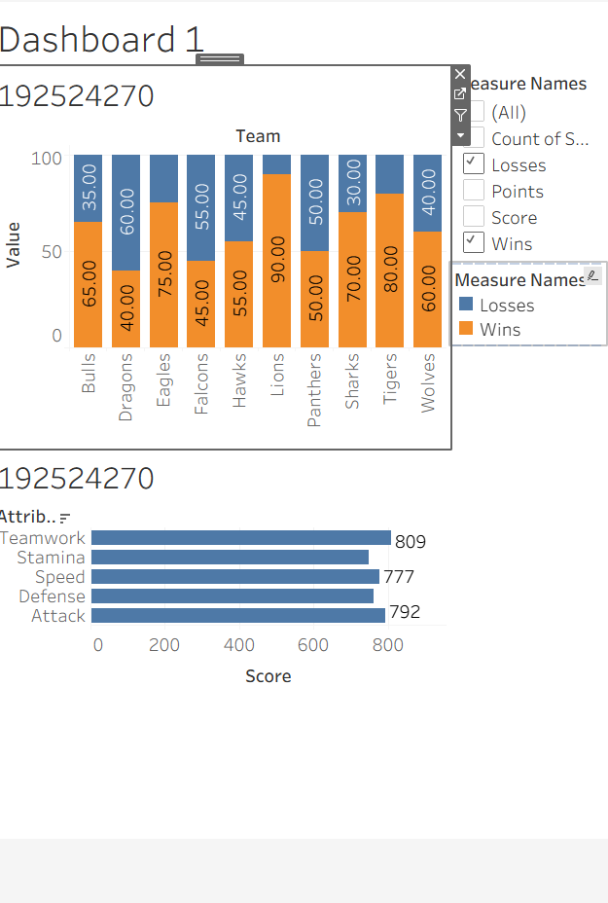
- Easier to identify high and low performers.

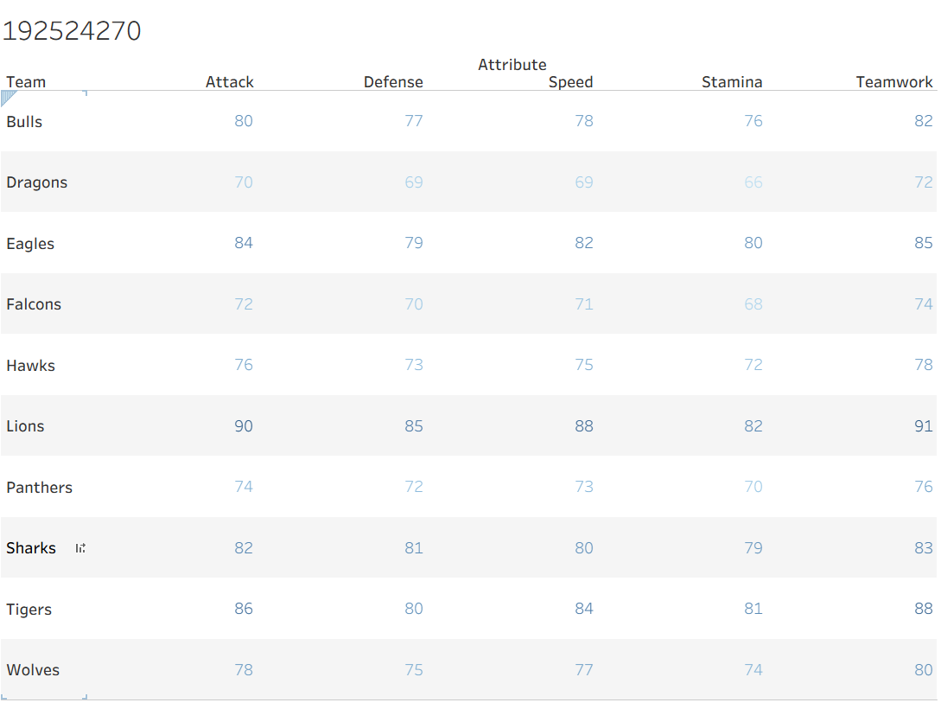
Conclusion
Choosing the correct chart type significantly improves the effectiveness of sports data visualization. Stacked bar charts clearly represent win-loss composition, while radar charts with a polar coordinate system effectively compare multiple attributes of a single team. A well-designed dashboard combining team rankings and attribute profiles provides a comprehensive overview that supports informed decision-making. However, when comparing all ten teams simultaneously, alternative visualizations such as parallel coordinates or heat maps are more appropriate than radar charts, as they reduce visual clutter and allow accurate comparison across multiple teams. Overall, selecting visualization methods based on the analysis objective leads to better understanding and communication of sports performance data.

Question 9
Introduction
Manufacturing industries rely heavily on data visualization to monitor supplier performance, product quality, and production efficiency. Charts and graphs help identify defects, evaluate delivery performance, and analyze production trends over time. By selecting appropriate visualization techniques, manufacturers can quickly detect potential risks, recognize seasonal patterns, and make informed decisions to improve operational performance. This case study focuses on choosing suitable charts for supplier analysis and production monitoring.
Objective
The main objective of this case study is to identify the most effective visualization methods for analyzing supplier and production data. It aims to determine the appropriate axis scale for defect rate analysis, design a chart that combines shipment volume with on-time delivery performance, and recommend a suitable chart for displaying two years of production trends. The study also explores the use of a diverging color scale to visualize defect rate deviations from a target value, enabling easier identification of suppliers performing above or below the expected quality standard.
Supplier | Shipment Volume | On-Time Delivery (%) | Defect Rate (%) | Jan | Feb | Mar | Apr | May | Jun
S1 | 1000 | 98 | 1.5 | 950 | 970 | 980 | 990 | 1000 | 1020
S2 | 900 | 95 | 2.0 | 850 | 860 | 870 | 880 | 900 | 910
S3 | 850 | 92 | 3.5 | 800 | 810 | 830 | 840 | 850 | 860
S4 | 750 | 90 | 4.0 | 700 | 710 | 720 | 730 | 740 | 760
S5 | 650 | 88 | 5.5 | 620 | 630 | 640 | 650 | 660 | 670

a) What axis scale is required for the defect rate data given its range, and why?
Answer:
Use a Linear Y-axis scale starting from 0% up to slightly above the maximum defect rate (for example, 0–10% if the highest value is below 10%).
Reason:
- Defect rates usually have a small numerical range.
- A linear scale accurately represents differences.
- Avoids exaggerating small variations.
b) Design a chart combining supplier shipment volume and on-time delivery rate, annotating the supplier posing the greatest risk.
Answer:
Chart Type: Combination Chart
- Bar Chart: Shipment Volume
- Line Chart: On-Time Delivery Rate (%)
Annotation:
Highlight the supplier with:
- High shipment volume
- Low on-time delivery rate
Narrative Example:
"Supplier C represents the greatest operational risk because it handles high shipment volumes while maintaining the lowest on-time delivery rate."

c) Propose a chart for the 2-year production volume trend, and explain how you would highlight any seasonal patterns.
Answer:
Chart Type: Line Chart
How to highlight seasonal patterns:
- Plot monthly production over two years.
- Use different colored lines for each year.
- Add markers for each month.
- Shade recurring high-production periods or annotate seasonal peaks.
This makes repeating seasonal increases and decreases easy to identify.

d) Explain how a diverging color scale could be used if defect rates were instead expressed as a deviation from a target rate (some suppliers above target, some below).
Answer:
Use a diverging color scale centered at the target value.
- Green: Below target (better performance)
- White/Neutral: At target
- Red: Above target (worse performance)
Benefit:
- Quickly identifies suppliers performing better or worse than the target.
- The farther the color from the center, the greater the deviation.
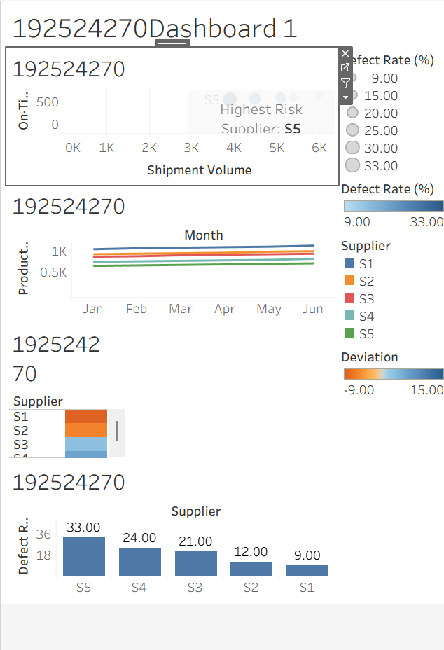

Conclusion
Selecting suitable visualization techniques improves the accuracy and clarity of manufacturing performance analysis. A properly scaled axis ensures defect rates are represented without distortion, while a combination chart effectively highlights suppliers with high shipment volumes and poor delivery performance. A line chart is ideal for illustrating two-year production trends and seasonal variations, making recurring patterns easy to identify. Furthermore, using a diverging color scale to represent deviations from the target defect rate allows decision-makers to distinguish between acceptable and problematic supplier performance at a glance. Overall, appropriate data visualization supports better quality control, supplier evaluation, and production planning.

